Management, Organizational Culture and Communication Skills Analysis Report Draft
SAMPLE / DRAFT REPORT — All figures, percentages and findings in this document are fictitious (mock) data; they do not reflect an actual TURAM analysis process or a real business. The purpose is to illustrate the report format delivered under the Management, Organizational Culture and Communication Skills Analysis service.

Executive Summary
The analysis measures manager profiles, employee motivation dynamics and organizational culture. Key finding: according to the Competing Values Framework, the business shows a predominantly Clan/Family Culture profile with a 38% share, while Innovative Culture has the lowest share at 13%.

Methodology and Data Scope
- Participants: 142 employees (survey) + 12 department/unit managers (semi-structured interviews)
- Departments: Front Office, Housekeeping, Food & Beverage (F&B), Kitchen, Management/Administration
- Measurement tools: Organizational culture index survey (5-point Likert scale), manager–employee interaction quality interview protocol
- Data collection period: 4 weeks

Organizational Culture Index
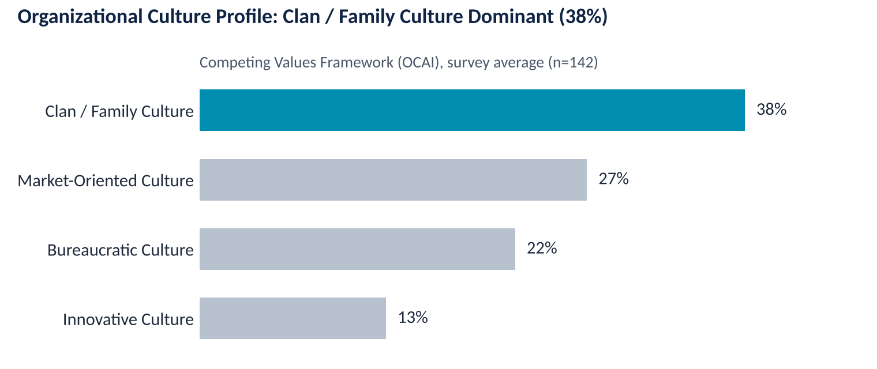
Sample/draft data · survey average, n=142
According to the Competing Values Framework (OCAI), the business shows a predominantly Clan/Family culture profile, indicating strong team belonging and collaboration but a weak Innovative culture (13%).
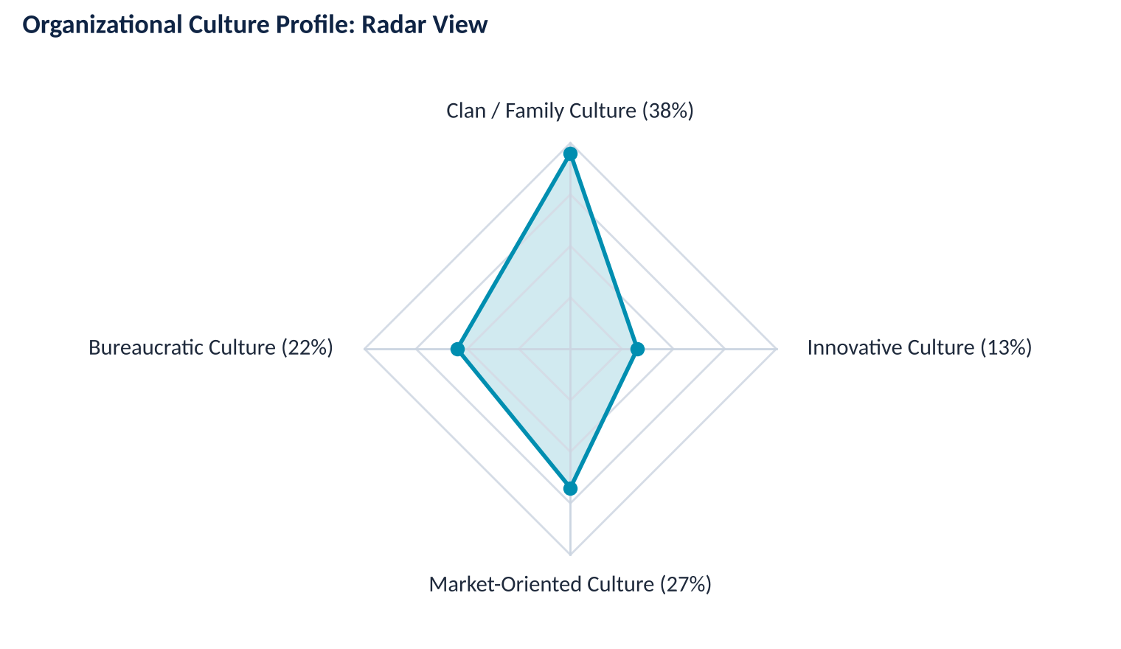
Sample/draft data · overall average, n=142
This radar view compares the 4 culture types in a single chart based on the overall average. If requested, the same radar view can also be produced separately for each department.

Employee Engagement by Unit
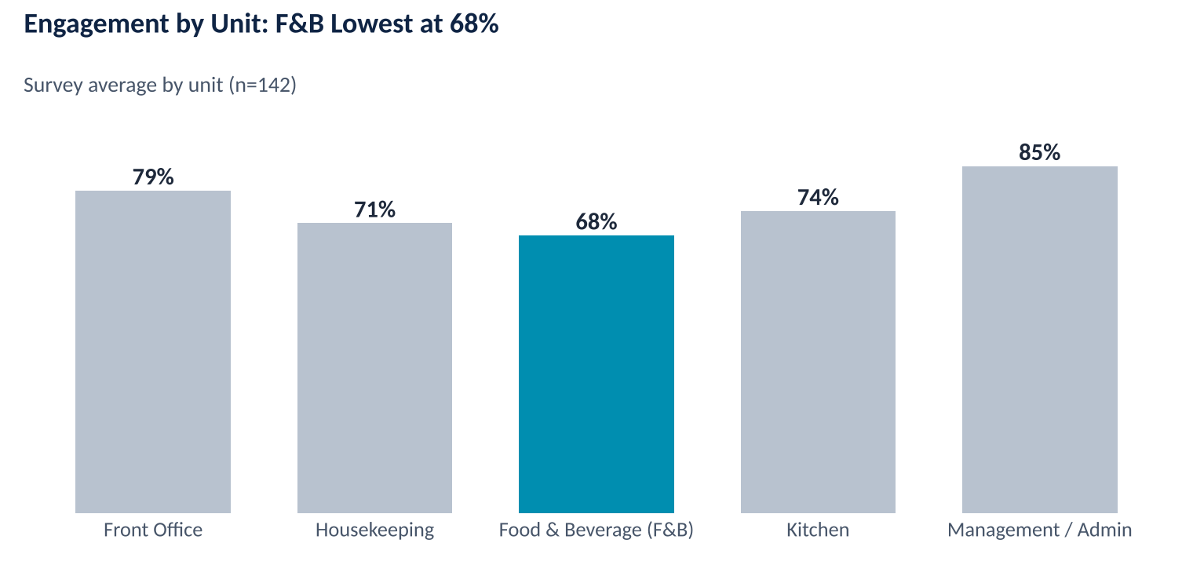
Sample/draft data · survey average, n=142
The Food & Beverage (F&B) department trails the highest-scoring Management/Administration unit by 17 points, standing out as a priority area for a focus group study.

Unit-Based Leadership Action Plan
In this stage, where units are assessed individually, the dominant organizational culture and leadership type in the unit are evaluated and interpreted according to the needs of the department.
Below is a sample list of recommendations for one unit:
- Establish regular department meetings and suggestion systems that increase employee participation in decision-making.
- Strengthen vertical communication channels and spread an empowerment-oriented leadership approach.
- Conduct a focus group study specific to the F&B department to examine in depth the factors that reduce engagement.
- Make the recognition and reward system more transparent and increase its frequency.
- Repeat the organizational culture index twice a year to track trends.
- ....

Conclusion
This draft illustrates the framework that will be filled with the business's own survey and interview data in an actual TURAM analysis process. In practice, data collection is typically completed within a 4-week period, and the findings are reported as a concrete, department-based leadership development plan. The reporting process takes 3 weeks.

