TURAM

Big Data and Advanced
Analytics Services
Sample Hotel Analytics Report
Illustrates demand forecasting, channel performance, RFM-based guest segmentation, topic-based sentiment analysis and churn risk modeling through a fictitious 320-room resort hotel scenario.
All numerical values, person and business information in this document have been generated synthetically for demonstration purposes.
Purpose of the report
To show how business data can be turned not merely into description, but into analytical outputs that support operational decisions.
SAMPLE REPORT | 2026

01. Executive Summary
Sample analytical findings and priority management actions at a glance
This sample study shows that PMS, CRM, reservation channel and online review data can be addressed within the same decision framework. The outputs are organized to link forecasting, segmentation, text analytics and churn modeling with management actions.
77%  Week 8 Forecast Occupancy  Peak of 91% in week 6 | 38%  Direct Web Share  OTA share 44% | 8%  High Churn Risk  Within the loyalty base | Check-in  Most Critical Experience Topic  31% negative sentiment

Key management insight
Although overall satisfaction appears high, topic-based analysis shows that negativity is concentrated particularly in check-in/reception and room-cleanliness experiences. The high cancellation rate on the OTA channel and the behavioral slowdown among high-value guests during the same period call for revenue and CRM actions to be addressed together.

Recommended priorities
- Gradually narrow discount inventory and strengthen rate protection in weeks with high booking pickup.
- Run conversion campaigns on the direct web channel targeting loyalty members and repeat guests.
- Launch an operational root-cause review of check-in time and room-cleanliness touchpoints.
- Apply personalized win-back actions for high-value guests whose visit frequency is declining.

02. Data Scope and Analytical Approach
Data sources, data security and modeling logic
Operational and digital data that may be used in the analysis are processed in an anonymized or pseudonymized format in accordance with the Personal Data Protection Law (KVKK). Personal identity information is masked before analysis; reporting is done at an aggregated level.
DATA SOURCES  PMS and reservations  CRM and loyalty  Web / OTA channel data  Online reviews | ANALYTICS  Demand forecasting  RFM segmentation  Topic + sentiment  Churn modeling | MANAGEMENT ACTION  Pricing & inventory  Channel strategy  Experience improvement  CRM win-back

Model note
The model types and variables shown in this document are examples. In a real project, the algorithm is selected based on data quality and validation performance; explainability and operational usability are assessed together.

03. Demand Forecasting, Occupancy and Channel Performance
Reading booking pace, channel mix and cancellation behavior together
Instead of basing occupancy forecasts only on past occupancy rates, the current reservation level, booking pickup, lead time, season, day type, price, channel mix and cancellation behavior can be considered together.

Sample variable set
Variable group | Sample indicators
Demand signals | On-the-books occupancy, booking pickup over the last 7/14/30 days, average booking lead time
Pricing & inventory | ADR, room-type availability, promotion/discount status
Calendar | Day of week, month/season, public holiday or local event indicator
Distribution channel | OTA share, direct website share, tour operator share
Cancellation behavior | Overall cancellation rate and channel-level cancellation rates

Sample 8-week occupancy forecast
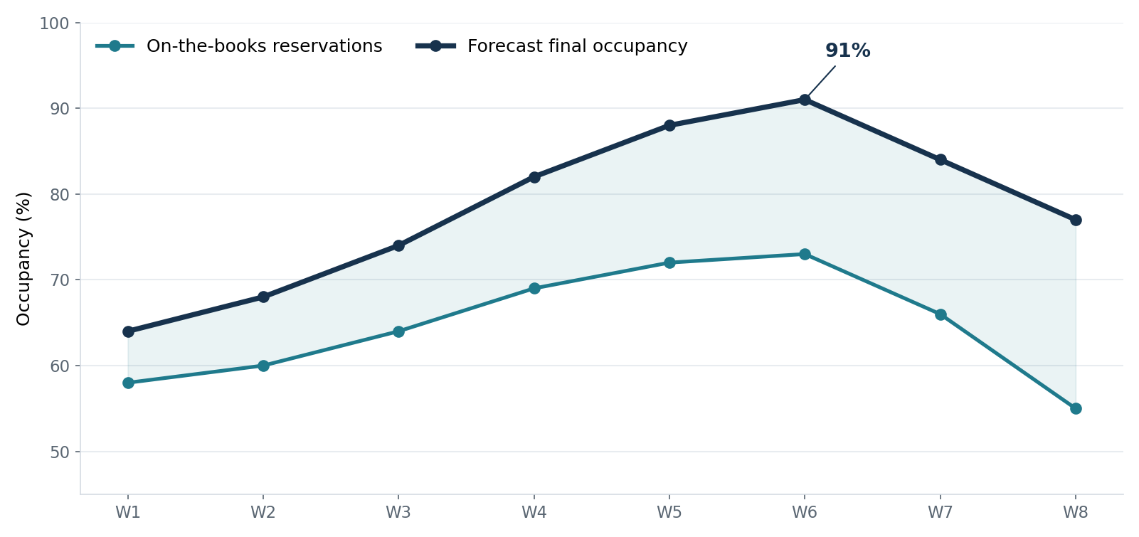
Figure 1. The gap between the current reservation level and forecast final occupancy shows the remaining sales potential.
Management commentary
Forecast occupancy reaches 91% in week 6. In this period, reducing discount inventory, protecting rates on high-demand room types and bringing staff planning forward can be considered.

Channel mix and cancellation rate
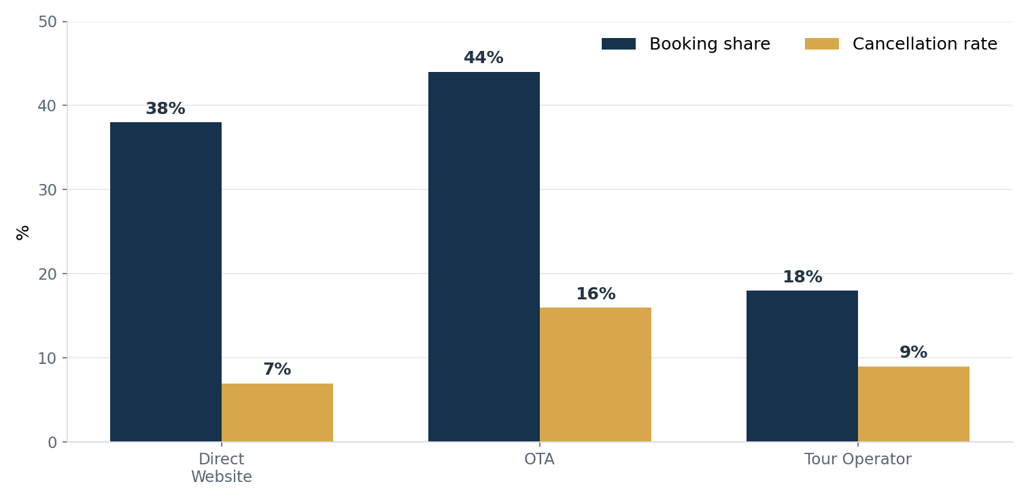
Figure 2. Channel share alone is not sufficient; it should be monitored together with cancellation behavior and net realized revenue.
Sample finding
The OTA channel accounts for 44% of total reservations, with a sample cancellation rate of 16%. On the direct web channel, the cancellation rate is 7%. This picture makes channel-level tracking of net room-nights and net revenue meaningful.

04. Guest Segmentation and RFM Analysis
Turning Recency, Frequency and Monetary behavior into action
RFM analysis separates guests behaviorally by their most recent stay (Recency), repeat frequency (Frequency) and spending level (Monetary). Depending on the business, variables such as average length of stay or ancillary spend can also be added.
Segment | Share | Recency | Frequency | Monetary | Sample action
Loyal / High Value | 28% | Low | High | High | Loyalty privileges, direct booking offer
Price-Driven | 34% | Medium | Low-Medium | Medium | Price-sensitive, seasonal campaign
Experience Seekers | 22% | Medium | Medium | Very high | Premium service and personalization
One-Time / Opportunistic | 16% | High | Low | Low | Offer that triggers a second stay

Visual profile of RFM segments
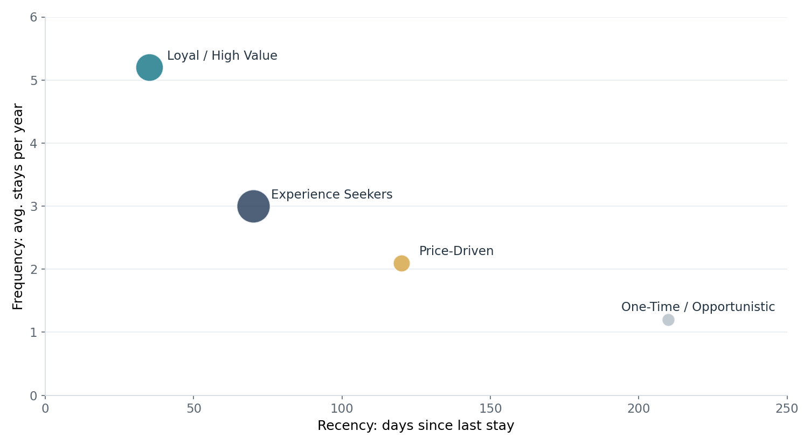
Figure 3. Bubble size represents monetary value; segments that are high-value but slowing down in behavior can provide an early warning for CRM.
Management commentary
The purpose of segmentation is not merely to produce “guest types”, but to differentiate offer, channel, service and win-back decisions. In particular, an increase in recency among guests with high monetary value can be monitored as an early churn signal.

05. Guest Voice Analytics: Topic Modelling + Sentiment
Moving from the overall sentiment rate to which experience area creates problems
Instead of classifying online reviews only as positive / neutral / negative, they can first be split into experience topics and the sentiment distribution calculated for each topic. In this way, it can be determined at which operational touchpoints an apparently low overall negativity rate is concentrated.
75%  Positive  all reviews | 9%  Neutral  all reviews | 16%  Negative  all reviews | 31%  Highest negativity  check-in / reception

Topic-based sentiment distribution
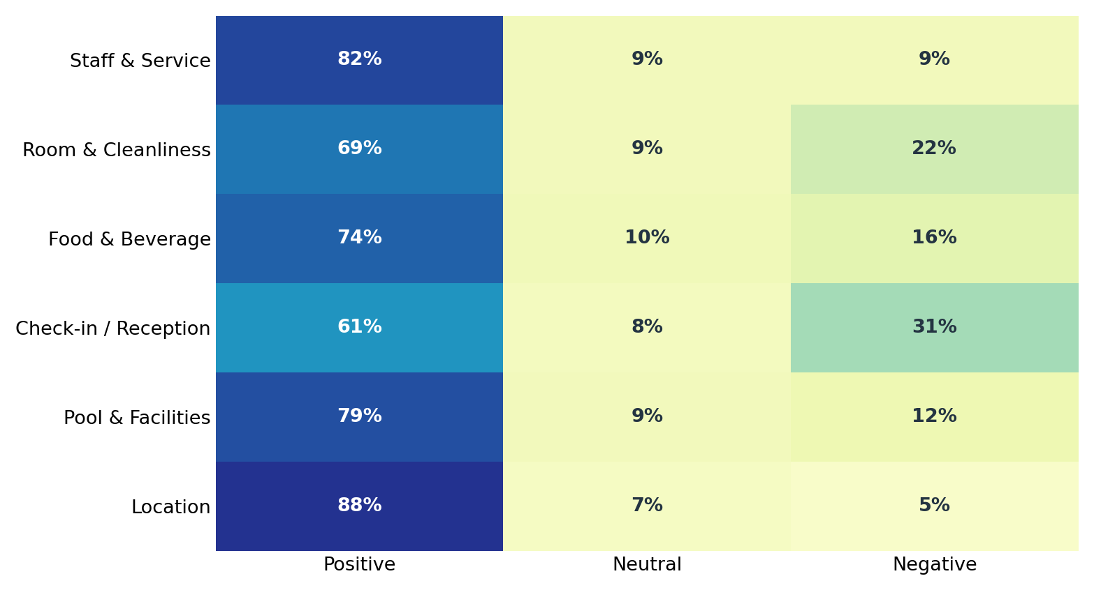
Figure 4. Topic-based sentiment analysis makes visible the operational concentrations that the overall sentiment distribution can hide.
Topic | Review Share | Positive | Neutral | Negative
Staff & Service | 27% | 82% | 9% | 9%
Room & Cleanliness | 23% | 69% | 9% | 22%
Food & Beverage | 19% | 74% | 10% | 16%
Check-in / Reception | 12% | 61% | 8% | 31%
Pool & Facilities | 11% | 79% | 9% | 12%
Location | 8% | 88% | 7% | 5%
Sample review cluster
Check-in / Reception: “Overall we were satisfied with the hotel; however, we waited a long time at check-in.” | Room & Cleanliness: “The room was comfortable but the cleanliness standard was not the same every day.” These examples are synthetic and are provided to illustrate the report format.
Management commentary
While negative sentiment is 16% across all reviews, it rises to 31% under the check-in/reception topic. Prioritization should be based on topic-level concentration, not on the overall sentiment rate.

06. Churn Risk Analysis
Seeing who is at risk of leaving and which behaviors increase the risk
The churn model brings together behavioral slowdown signals among guests in the loyalty base or with repeat-booking potential. The aim is not to deliver a definitive “will leave / will not leave” verdict, but to set intervention priorities.
71%  Low Risk  regular behavior | 21%  Medium Risk  early warning | 8%  High Risk  priority action | 3 months  Recommended Refresh  model update

High churn risk by segment
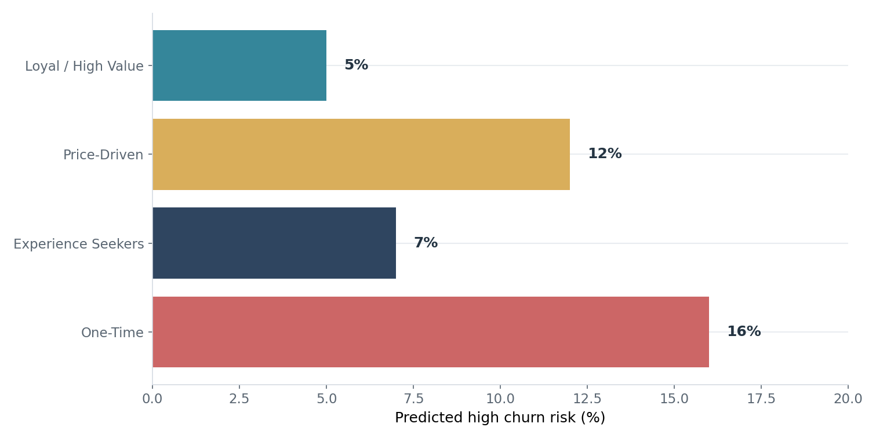
Figure 5. Segment-based risk rate enables prioritization instead of applying the same intervention to all guests.
Prioritization principle
A high risk rate alone should not determine where the CRM budget goes. By considering customer value, win-back likelihood and the appropriate communication channel together, high-value risk groups can be addressed first.

Sample churn drivers
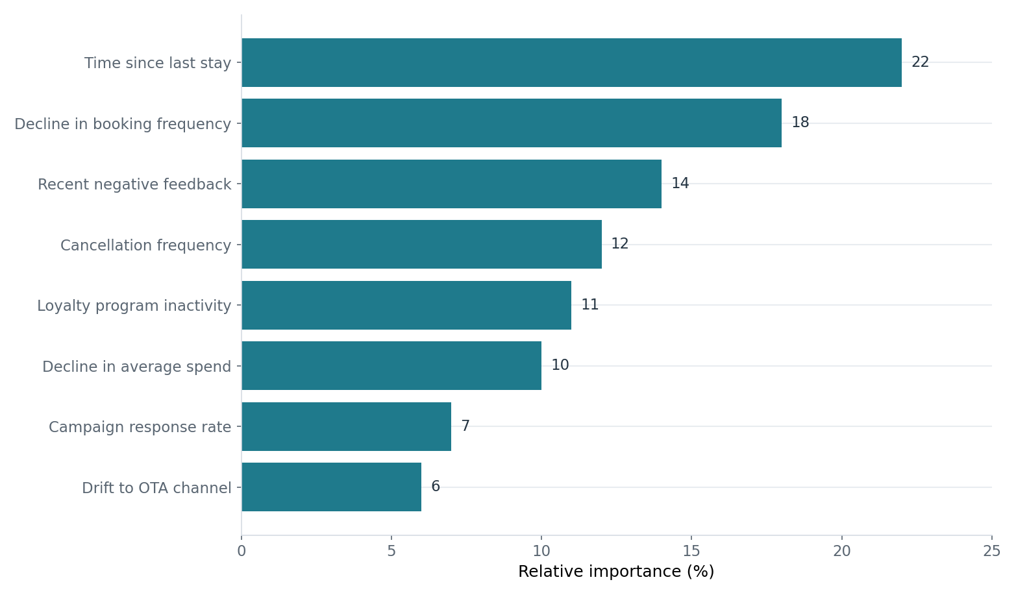
Figure 6. Relative importance values are illustrative; in a real project they are reported after model validation and explainability analysis.
How can the profile breakdown be used?
The churn rate can be examined separately across breakdowns such as market, booking channel, loyalty status and customer segment. Demographic variables such as age should not be interpreted as a management conclusion on their own; they should be evaluated together with behavioral and channel variables.

07. Management Action Plan
Linking analytical output to measurable decisions and tracking indicators
Area | Analytical signal | Recommended action | Tracking KPI
Revenue Management | Fast booking pickup before week 6 | Reduce discount inventory; increase rate protection by room type | Net ADR, RevPAR, pickup
Distribution | OTA share 44% and cancellations 16% | Direct web conversion and loyalty offer | Direct share, channel-level cancellations
Guest Experience | Check-in negativity 31% | Review waiting time and shift capacity | Check-in time, topic sentiment
Housekeeping | Room/cleanliness negativity 22% | Monitor quality control and recurring complaint codes | Cleanliness complaint rate
CRM | High churn risk 8% | Personalized win-back for the high-value risk group | Reactivation, repeat booking

Sample 90-day implementation sequence
Days 1–30: data quality control and KPI definitions. | Days 31–60: calibration of segment, topic-sentiment and churn models. | Days 61–90: monitoring selected actions through A/B or controlled pilot implementations and connecting them to the management dashboard.

Model and report maintenance cadence
- Demand / occupancy forecasting: daily or weekly data refresh, with more frequent monitoring according to season intensity.
- Topic + sentiment: weekly or monthly update depending on review volume.
- RFM segmentation: monthly or quarterly recalculation.
- Churn model: re-evaluation roughly every three months, together with performance tracking.

08. Conclusion
From sample report to real implementation
This sample report shows how a business can combine its PMS, CRM, digital channel and online review data in a single analytical framework. In a real implementation, the data sharing protocol, data dictionary and success KPIs are defined together; the modeling process is tailored to the business's data structure and the findings are converted into an action plan.
The numbers in this report are not real business results
All rates, segments, model outputs, review examples and visuals have been generated synthetically solely to illustrate the sample output format. In a real project, results are calculated using business-specific data.
TURAM | Big Data and Advanced Analytics Services
Sample report draft

