Lean Kitchen Efficiency Report (Draft)

All numbers, rates and findings in this document are fictitious data. Its purpose is to illustrate the report format delivered at the end of the Lean Kitchen Integration service.

Executive Summary
The analysis indicates that the current waste rate stands at xx% of food cost and that, with the proposed process improvements, it can be reduced to xx%. On this basis, a monthly savings potential of approximately TRY xx has been calculated.

Current State Analysis
Identifying the current workflow
Average monthly food cost: TRY xx
Observed total waste rate: xx% of food cost (approximately TRY xx/month)
Causes of waste:
- Failure to follow standard portion sizes during preparation (xx%)
- Overproduction at buffet setup without using historical occupancy data (xx%)
- Delays in expiry date tracking and spoilage losses (xx%)
- FIFO (first-in, first-out) principle not applied in cold storage layout (xx%)
- ....

Waste Distribution
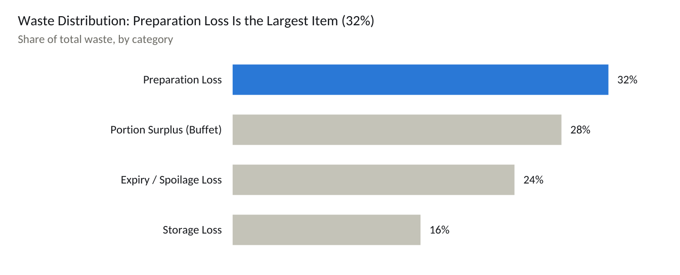
sample/draft data · four waste categories
Waste tracking, stage-by-stage evaluation, and then improvement recommendations for each stage

Workflow Evaluation
Sample workflow improvement proposal:
Current Flow: Procurement → Non-standard storage → Unmeasured preparation → Cooking → Fixed-quantity buffet setup → Service → Waste
Proposed Flow: Procurement → FIFO storage and labeling → Standard recipe/portion cards → Demand-forecast-based production plan → Cooking → Dynamic buffet replenishment → Service → Waste tracking and feedback loop
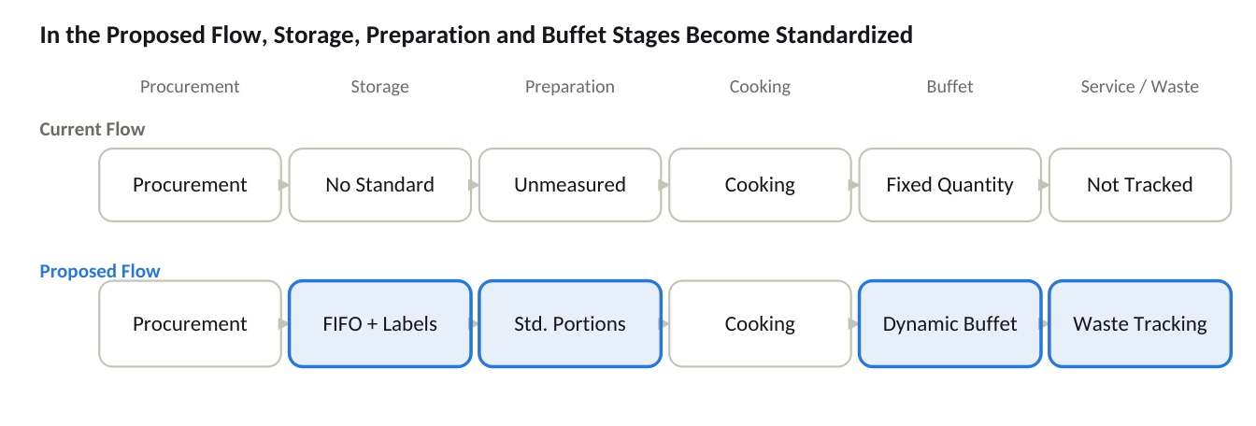
flow diagram · 6 stages, current vs. proposed comparison

Improvement Recommendations and Projected Savings
Sample improvement recommendations:
- Introduce standard portion cards and a digital recipe management system.
- Move to dynamic production planning at buffet setup based on historical occupancy data.
- Reorganize cold and dry storage according to the FIFO principle and apply a color-coded labeling system.
- Establish a daily waste tracking form and a weekly waste reporting cycle.
- Provide kitchen staff with refresher training on lean production and waste awareness every 3 months.
- .....
The recommendations above can be planned for implementation in phases; the draft table below shows a sample implementation timeline.
Phase | Period | Recommendations | Expected Impact
Phase 1 | Months 0-1 | Standard portion cards and digital recipe system; daily waste tracking form | Quick, low-cost, immediately measurable
Phase 2 | Months 1-3 | FIFO storage and labeling; weekly waste reporting cycle | Process discipline, medium-term impact
Phase 3 | Months 3-6 | Dynamic production planning based on occupancy data; staff training every 3 months | Lasting behavioral change, cumulative savings
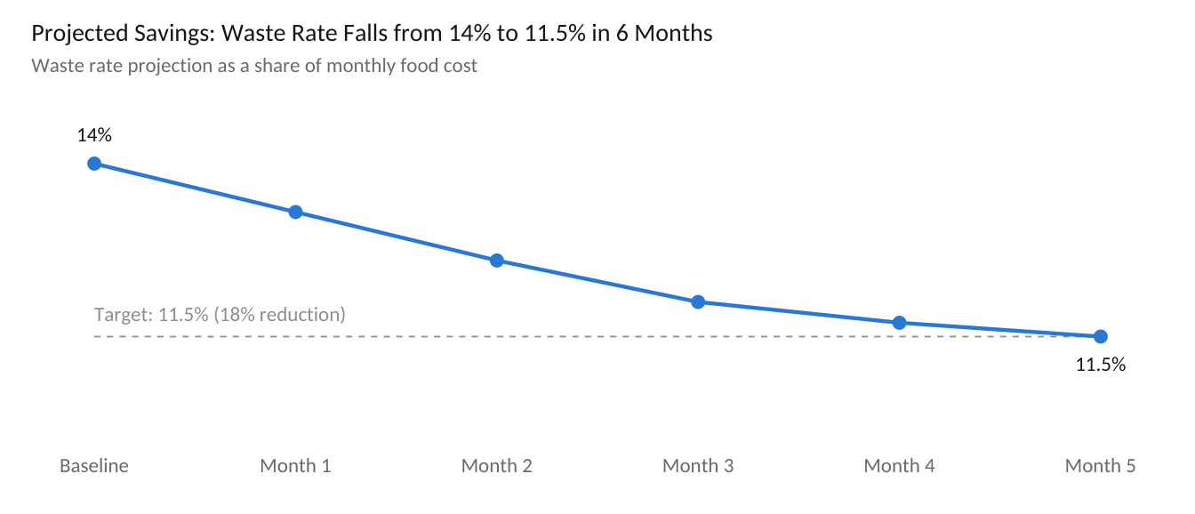
sample/draft data · 6-month projection

For example: with the proposed improvements, the waste rate is expected to fall to the 5-month target of 11.5%, which corresponds to savings of approximately TRY 46,000 per month and TRY 555,000 per year.

Conclusion
This draft illustrates the framework that will be filled in with the business's own data (POS, warehouse, recipe and staff records) in a real analysis process. In practice, the data collection process typically begins with a 4-6 week observation period, and the findings are converted into a business-specific action plan and reported. The action plan is designed to cover the short, medium and long term.

